Chapter 5: Multicore Processor Design
5.1–5.3 Core Integration, Memory Hierarchy & Cache Coherence
- What are the different levels of cache memories used in multi-core computers and why are they used? Explain. (2024 Fall)
- What are the essential factors to consider when designing and managing cache memory? Explain. (2024 Fall)
Cache memory is designed to provide fast access to frequently used data and instructions while balancing speed, capacity, cost, and hardware complexity. The important factors are:

1. Cache Performance
The main objective is to reduce the effective memory access time.
- Hit ratio: Percentage of memory requests found in the cache.
- Miss ratio: Percentage of requests not found in the cache.
- Hit time: Time required to find and access data in the cache.
- Miss penalty: Additional time required to obtain data from lower-level memory.
A good cache should have high hit ratio and low hit time.

2. Cache Mapping
A mapping technique determines where a main-memory block can be placed in the cache.
- Direct Mapping: Each memory block has only one possible cache location. It is simple and fast but can cause conflict misses.
- Fully Associative Mapping: A block can be placed anywhere in the cache. It reduces conflicts but requires more complex and expensive hardware.
- Set-Associative Mapping: A block maps to a particular set but can occupy any line within that set. It provides a balance between direct and fully associative mapping.

3. Block Size
The cache block or line size must be carefully selected.
- Larger blocks can exploit spatial locality and reduce compulsory misses.
- Very large blocks can reduce the number of blocks in the cache and increase cache pollution.
- Therefore, the block size should provide a good balance between locality and cache capacity.

4. Replacement Policy
When the cache is full, a replacement policy determines which block should be removed.
Common policies include:
- LRU (Least Recently Used): Removes the block that has not been used for the longest time.
- FIFO (First-In First-Out): Removes the oldest block.
- LFU (Least Frequently Used): Removes the least frequently accessed block.
- Random: Selects a block randomly.
The replacement policy should minimize cache misses without introducing excessive hardware complexity.

5. Write Policy
The cache must determine how modifications are transferred to lower memory.
- Write-Through: Every cache write is immediately written to lower-level memory. It is simple but generates more memory traffic.
- Write-Back: Data is written only to the cache initially and transferred to lower memory when the block is replaced. It reduces memory traffic but requires a dirty bit and more complex control.
- Write-Combining: Combines several small writes before sending them to memory, improving write efficiency.

6. Cache Organization
Cache can be organized as:
- Unified Cache: Stores both instructions and data.
- Split Cache: Separates instructions and data into I-cache and D-cache.
Split caches can allow instruction fetching and data access to occur simultaneously, improving processor performance.

7. Cache Size and Cost
Increasing cache size generally increases the chance of finding required data in the cache, but larger caches:
- Require more chip area.
- Increase manufacturing cost.
- May have greater access latency.
- Consume more power.
Therefore, cache size must be selected carefully.

8. Locality of Reference
Cache design depends heavily on program locality:
- Temporal locality: Recently accessed data is likely to be accessed again.
- Spatial locality: Data near a recently accessed location is likely to be accessed soon.
Effective cache design should exploit both types of locality.

9. Prefetching
Prefetching loads data into the cache before the processor actually requests it.
For example, when processing an array sequentially, the system can predict upcoming elements and load them in advance. This helps hide memory latency, although incorrect prefetching can waste bandwidth and cache space.

10. Multilevel Cache Organization
Modern processors commonly use L1, L2, and L3 caches.
CPU Core
↓
L1 → Very small and fastest
↓
L2 → Larger and slower
↓
L3 → Much larger and usually shared
↓
Main Memory → Very large but much slower
This hierarchy balances speed, capacity, and cost.

11. Cache Coherence in Multi-Core Systems
In multicore processors, different cores may have their own cache copies of the same data. Therefore, cache coherence must be maintained.
Protocols such as MESI and MOESI ensure that cores do not use outdated copies of shared data.

12. Compiler and Software Support
Software can improve cache performance by organizing data and computation to increase locality.
Examples include:
- Loop blocking
- Loop tiling
- Proper data layout
- Sequential memory access
These techniques reduce cache misses and improve overall performance.

Conclusion
The essential factors in cache design and management are performance, mapping technique, block size, replacement policy, write policy, cache organization, size and cost, locality, prefetching, multilevel hierarchy, cache coherence, and software support. The overall goal is to achieve high hit rates and low access time while keeping hardware cost and complexity reasonable.

- What is a multicore system? Why are the different hierarchies of memories used in a multicore system? Explain different multicore architectures with reference to cache memory organization. (2025 Fall Mock & 2025 Fall New)

1. What is a Multicore System?
A multicore system is a computer processor that contains two or more independent processing cores on a single chip. Each core can execute instructions independently, allowing multiple tasks or threads to execute in parallel.
Each core generally contains its own:
- ALU and execution units
- Registers
- L1 cache
- Sometimes a private L2 cache
The cores may also share a higher-level cache such as L3 and the main memory.
Example: A quad-core processor has four independent processing cores, so it can execute multiple threads concurrently.

2. Why Are Different Memory Hierarchies Used?
A multicore system uses several levels of memory because no single memory technology can provide high speed, large capacity, and low cost simultaneously.

1. Speed Difference
Processors operate much faster than main memory. If the CPU had to access DRAM for every instruction and data request, the cores would spend considerable time waiting.
Therefore, faster memories such as caches are placed close to the processor.

2. Cost and Capacity
There is a trade-off between speed, capacity, and cost:
- Registers → fastest, smallest, expensive
- L1 cache → very fast, small
- L2 cache → larger but slower
- L3 cache → larger and slower
- Main memory → much larger but slower
- Secondary storage → very large but much slower
Thus, frequently used data is kept in smaller and faster memory.

3. Principle of Locality
Programs normally exhibit two important types of locality:
- Temporal locality: Recently used data is likely to be used again.
- Spatial locality: Data located near recently accessed data is likely to be accessed soon.
Caches exploit these properties to reduce the average memory access time.

Memory Hierarchy
Faster
↑
Registers
│
L1 Cache
│
L2 Cache
│
L3 Cache
│
Main Memory
│
Secondary Storage
↓
Larger

3. Multicore Architectures Based on Cache Organization
Multicore processors can be classified according to whether their caches are private, shared, or a combination of both.

A. Private Cache Architecture
In a private cache architecture, each core has its own dedicated cache.
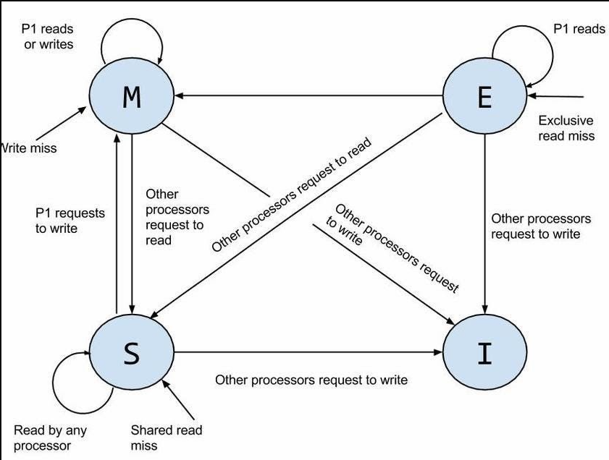

Advantages
- Very fast access to local cache.
- Cores do not directly compete for private cache space.
- Good performance for independent tasks.

Disadvantages
- The same data may exist in multiple caches.
- Cache coherence becomes necessary.
- Hardware protocols such as MESI/MOESI may be used to keep cached copies consistent.
Example: If Core 1 changes a shared variable, the system must ensure that Core 2 does not continue using an outdated copy.

B. Shared Cache Architecture
In a shared cache architecture, multiple cores use the same cache, commonly an L2 or L3 cache.
Core 1 ──┐
Core 2 ──┤
Core 3 ──┼── Shared Cache ── Main Memory
Core 4 ──┘

Advantages
- Cache space can be dynamically shared among cores.
- Reduces duplication of shared data.
- Data can be easily shared between cores through the common cache.

Disadvantages
- Multiple cores may compete for cache capacity and bandwidth.
- Heavy workloads can create cache contention.
- Shared-cache access may be slower than a private L1 cache.

C. Hybrid Cache Architecture
A hybrid architecture combines private and shared caches. This is common in modern multicore processors.
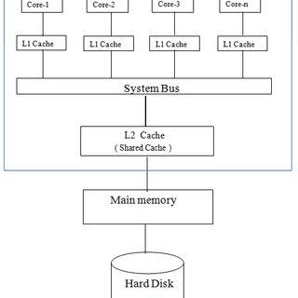

Features
- L1: Usually private to each core and very fast.
- L2: Often private to each core and larger than L1.
- L3: Usually shared by all cores and larger than L2.
- Main memory: Shared by all cores.

Advantages
- Very fast access through private L1/L2 caches.
- Shared L3 provides efficient communication and data sharing.
- Reduces the need to access slower main memory.
- Provides a good balance between performance, capacity, and cost.

Disadvantage
The system requires cache-coherence mechanisms to ensure that different cores have a consistent view of shared data.

Comparison
Feature | Private Cache | Shared Cache | Hybrid Cache
Cache ownership | Each core has its own cache | Cache shared by cores | Private + shared
Access speed | Very fast | Relatively slower | Fast
Cache contention | Low | Higher | Moderate
Data duplication | Possible | Reduced | Controlled
Coherence complexity | Higher | Lower at shared level | Requires coherence
Flexibility | Lower | High | High
Common use | Individual core caches | Shared L3 | Modern multicore processors

Conclusion
A multicore system contains multiple processing cores on a single chip and uses a hierarchical memory system to reduce the large speed gap between processors and main memory.
The three major cache organizations are:
Private cache: Each core has its own cache.
Shared cache: Multiple cores use a common cache.
Hybrid cache: Each core has private lower-level caches, while a higher-level cache is shared.
Hybrid architecture is widely used because it combines the low latency of private caches with the efficient data sharing of a shared cache.

- Briefly describe the different cache coherence protocols and their role in maintaining data consistency. (CA / Old)
- Briefly explain the key design considerations for cache memory and management. (CA / Old)
5.6 GPU Architectures and GPGPU
- What is a GPU? Explain the basic architecture of GPU. (2025 Fall Mock & 2025 Fall New)

What is a GPU?
A Graphics Processing Unit (GPU) is a specialized processor designed for highly parallel computation. Originally developed for graphics rendering, modern GPUs are also used in GPGPU computing, HPC, machine learning, and data-intensive applications. Unlike CPUs, which use a few powerful cores, GPUs use thousands of smaller cores to achieve high throughput and hide memory latency.

Basic Architecture of GPU
The basic architecture consists of the following components:
- Streaming Multiprocessors (SMs):
The main processing units of a GPU. Each SM contains many CUDA cores that execute multiple threads in parallel.
- Warp Scheduler:
Threads are organized into warps, normally containing 32 threads. The warp scheduler manages and executes these threads efficiently.
- Shared Memory:
A fast, low-latency on-chip memory within each SM. It allows threads in the same thread block to quickly share and reuse data.
- Global Memory:
Large off-chip DRAM shared by all SMs. It provides high memory bandwidth but has higher latency than shared memory.
- SIMD/SIMT Execution:
GPUs use SIMD/SIMT-style parallel execution, allowing many threads to perform similar operations on different data simultaneously.
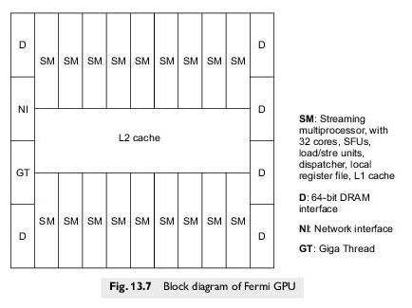
In summary: A GPU combines SMs, CUDA cores, warp scheduling, shared memory, and high-bandwidth global memory to execute thousands of threads concurrently and provide high computational throughput.

